HKMA C-RAF Compliance for Log360
Strengthen cybersecurity and meet HKMA C-RAF compliance with Log360.
Region: Hong Kong | Type: Cybersecurity Framework, Incident Management | Category: Compliance | Pricing: Free

Overview
The HKMA C-RAF compliance extension in Log360 helps organizations meet the HKMA Cyber Resilience Assessment Framework (C-RAF 2.0), the Hong Kong Monetary Authority framework requiring authorized institutions to assess cyber risk profiles and benchmark defense capabilities by providing centralized log management, real-time threat detection, and incident response tracking. The platform supports HKMA C-RAF requirements for governance, cyber risk identification, protection and access control, threat detection, incident response, situational awareness, and third-party risk management.
For Governance and Risk Oversight, Log360 tracks AD user auditing, GPO configurations, group and OU management, computer auditing, and policy changes to evidence governance. To address Cyber Risk Identification and Asset Management, the platform monitors Windows program inventory, software update status, registry changes, computer auditing, and vulnerability scanner integration. The extension also supports Protection and Access Control by providing capabilities that captures Windows and Unix logon/failed logon events, AD and Entra ID MFA logon compliance reports.

Key Features
- Threat Detection and Security Monitoring: Log360 delivers threat detection via FireEye, Trend Micro, Windows/Unix threat reports, and network attack monitoring.
- Incident Response and Recovery: Log360 monitors Backup and Disaster Recovery infrastructure, jobs, and Windows Backup events alongside FireEye and threat analytics.
- Situational Awareness and Threat Intelligence: Log360 aggregates Windows system events, EventLog data, FireEye reports, Trend Micro security data, and network attack logs for situational awareness.
- Third-Party Risk Management: Log360 audits cloud storage integration, AWS IAM activity, failed/unauthorized cloud activity, and cloud user login events.

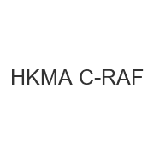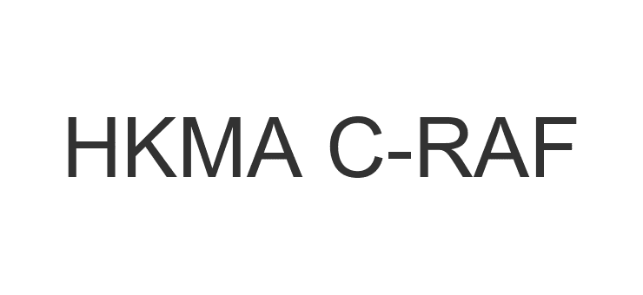
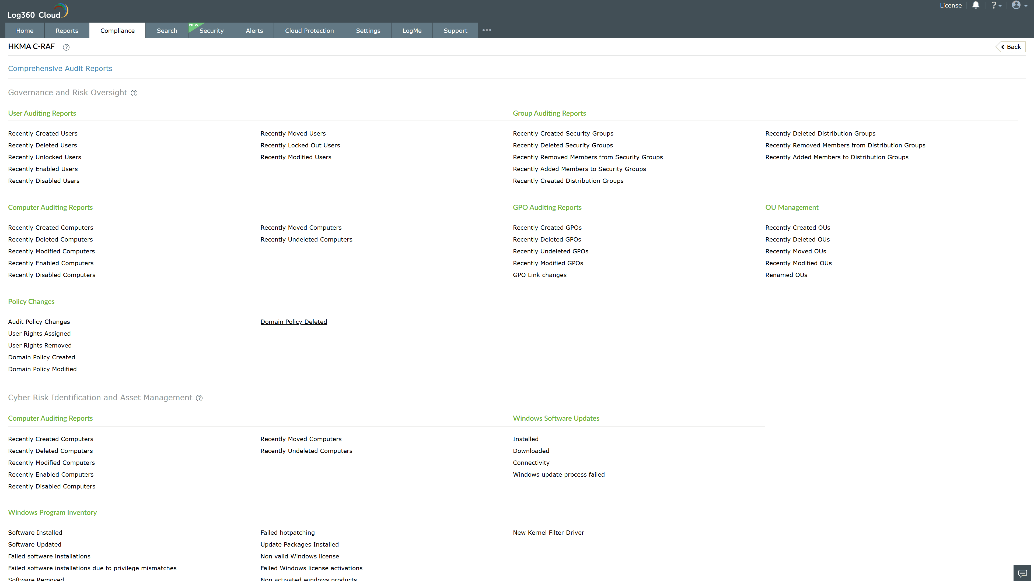
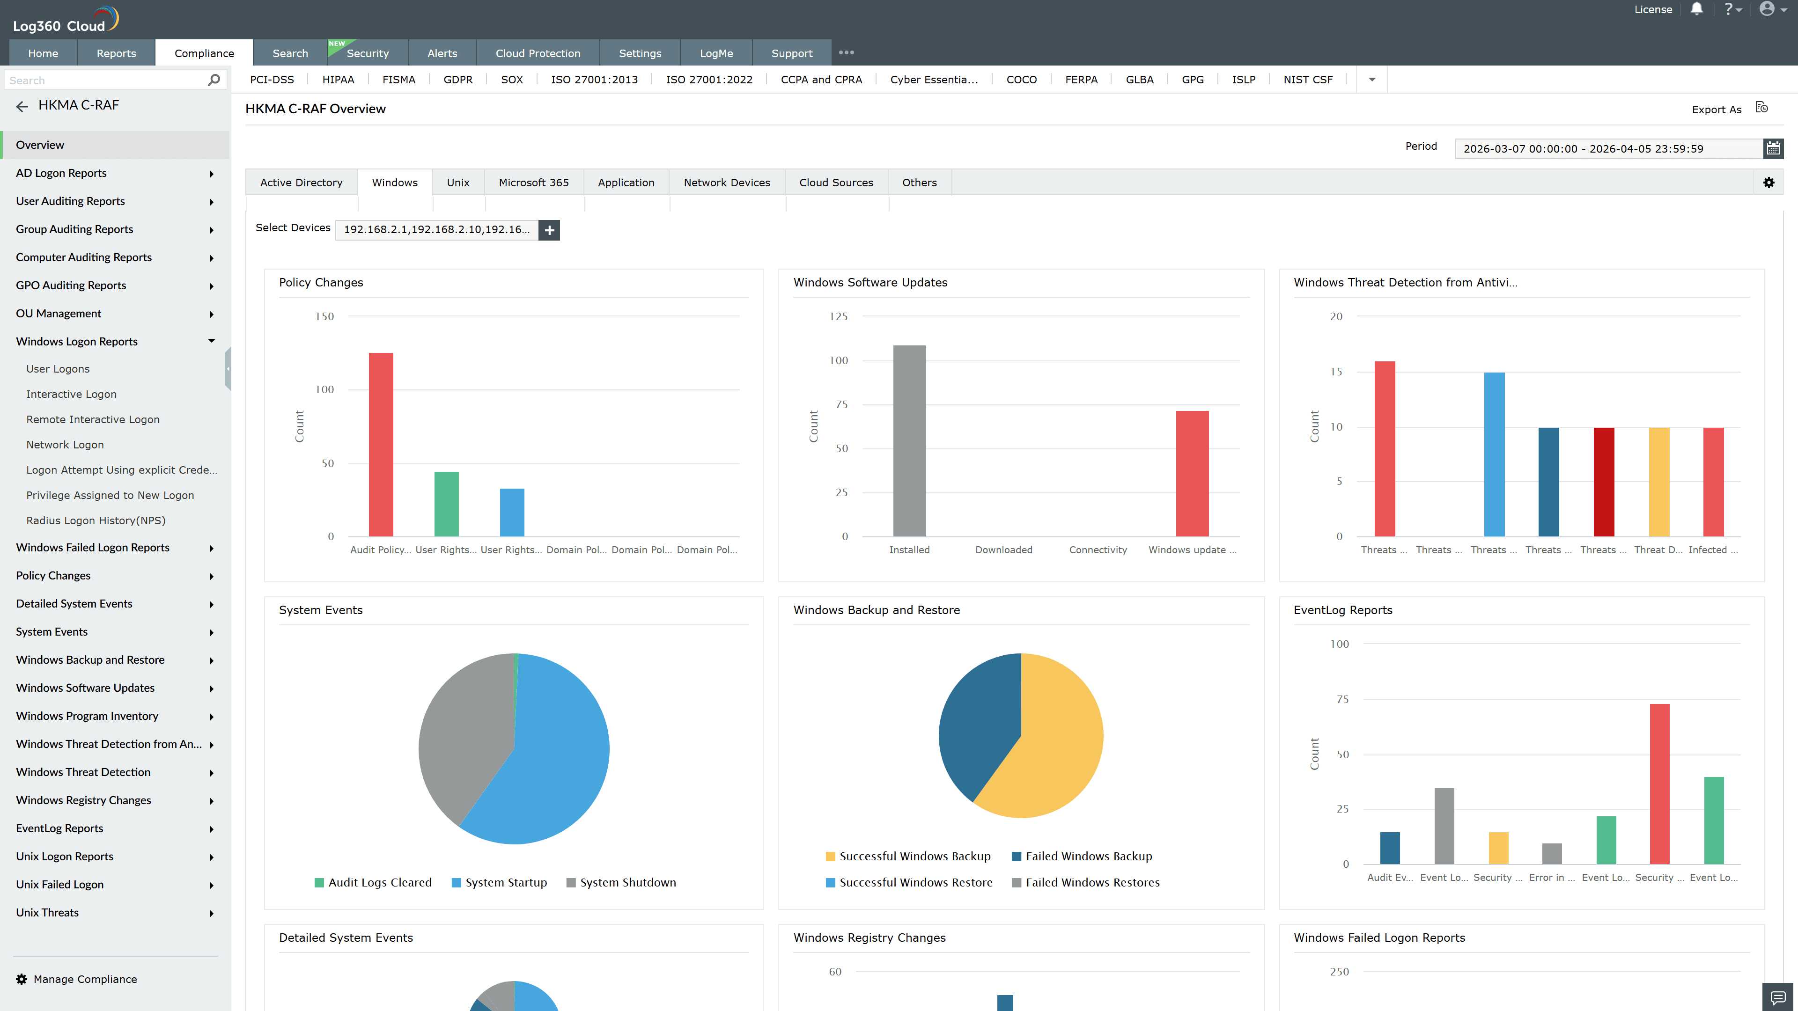
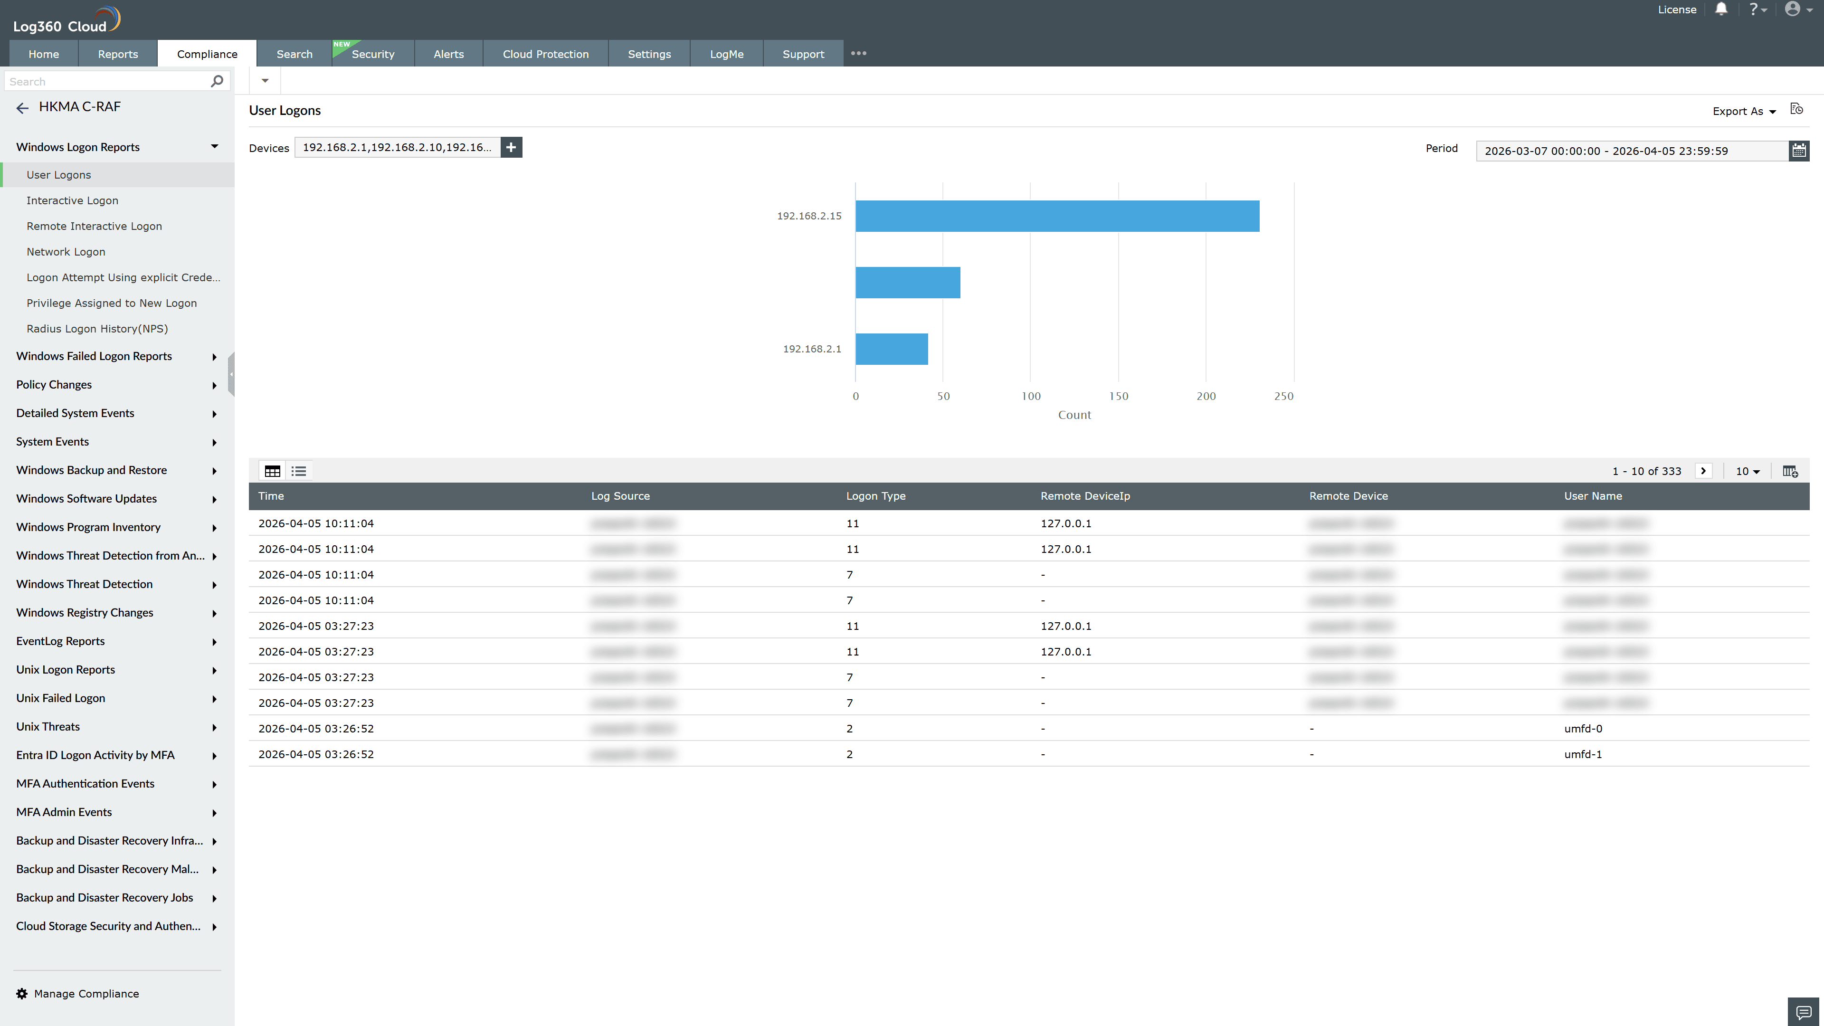
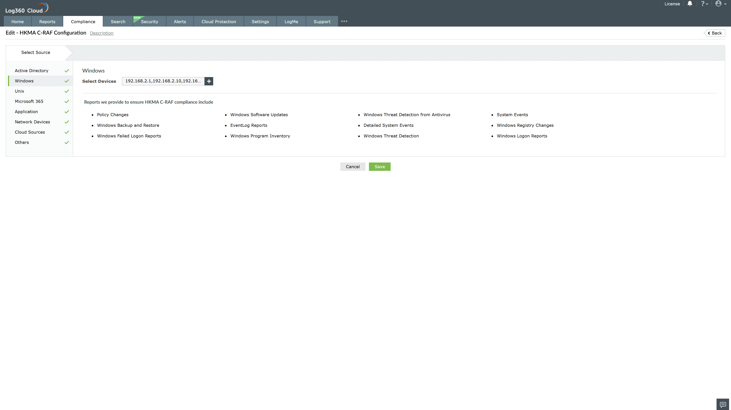
Valid Submission : Yes
Supported Editions : Free, Basic, Standard, Professional, MSSP
Help Document : https://www.manageengine.com/log-management/help/integrations/compliance-extensions.html
Help Video : Not provided
Tags : Log360, Compliance, Privacy monitoring, Data privacy, Regulatory compliance
Supported DCs : US, IN, JP, CA, AU, UK and EU
Privacy Policy:
Terms of Service:
Release Notes:
Predefined reports for the HKMA C-RAF.

